Louisiana Tech University
ELEN 479 Automatic Control Systems Lab
Lab 5: System Stability

Aim
To determine the stability of a system using Routh Hurwitz method.

Background
The Routh-Hurwitz criterion is a method by which one can investigate the stability of a system. In this lab the stability of the torsional control plant will be investigated.
Stability: A system is said to be stable, if its output is under control. Otherwise, it is said to be unstable. A stable system produces a bounded output for a given bounded input.
Like in the following diagram, if the marble is at the bottom of the bowl (stable), a small flick will make the marble oscillate but eventually settle back to its original position. However, if the marble is at the top of an inverted bowl (unstable), a small flick will make the marble fall off the bowl and never come back to the original position.
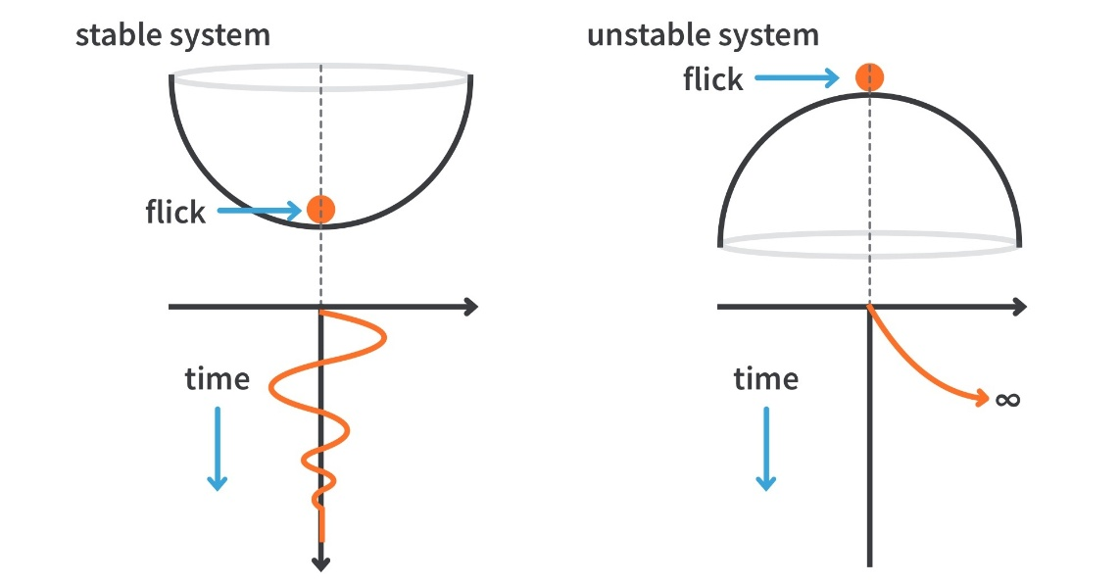
BIBO Stability: one definition of stability is Bounded Input Bounded Output (BIBO) stability. For any bounded input signals, if the system output is also bounded, then the system is stable; otherwise, the system is unstable.
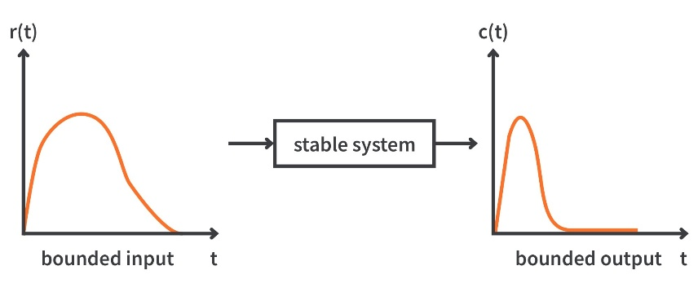
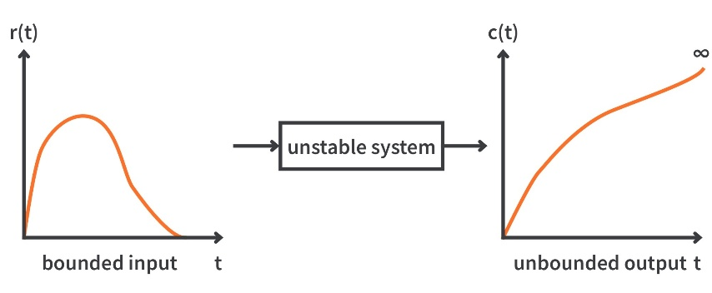
Poles and Stability: System poles will affect system’s output. For a system, if all system poles are on the left side of the s-plane, the system is stable; otherwise, the system is unstable.
For instance, if the system transfer function is $G\left(s\right)=\frac{1}{s+2}$, the pole is at $-2$. The system response of an impulse input is plotted as:
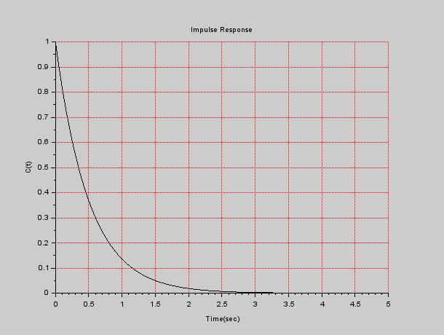
As we can see, it is bounded. Thus, the system is stable.
On the other hand, if the system transfer function is $G\left(s\right)=\frac{1}{s-2}$, the pole is at $2$. The system response of an impulse input is plotted as:
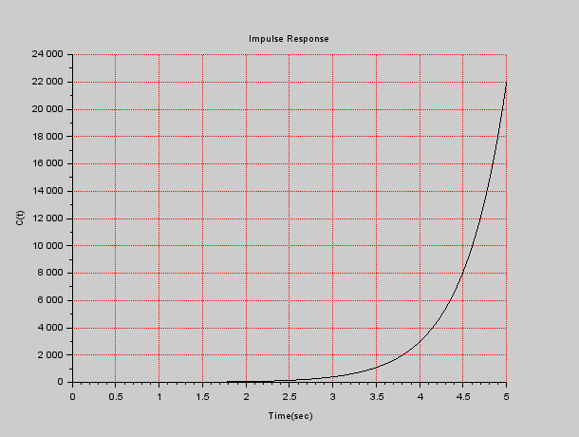
As we can see, it is not bounded. Thus, the system is unstable.
If all poles of a system lie in the left half of the s-plane (i.e., negative side) -> The system is stable.
Routh-Hurwitz Criterion: For high-order systems, it is difficult to find all poles.
For instance, if the system transfer function is $\frac{s+2}{s^{5}+2s^{4}+3s^{3}+2s^{2}+s+1}$, to find all poles, we need to solve the equation:
$s^{5}+2s^{4}+3s^{3}+2s^{2}+s+1=0$.
As you can see, this is not a easy task. Routh-Hurwitz (RH) Criterion provides us an alternative way to determine system stability without solving for system poles.
Steps in RH Criterion:
Step 1: First, we need to check the system’s characteristic equation, which is the denominator of the system’s transfer function. The general form is
$$q\left(s\right)=a_{n}s^{n}+a_{n-1}s^{n-1}+…+a_{1}s+a_{0}$$
We first check all coefficients of $q(s)$ should have the same sign (+ or -).
Also, there should be no missing terms (i.e., coefficients $a_{n}…a_{0}$ cannot be 0).
Step 2: Get the Routh Array.
To generate a Routh Array, we need to arrange the coefficients of $q(s)$ in a manner as shown:
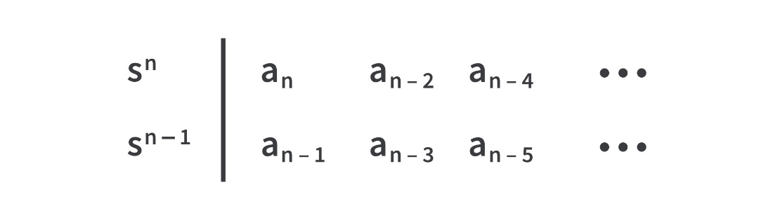
As you can see, it is just writing the coefficients alternatively in the first and second row of the array starting with the first row.
Starting on the third row, we need to calculate:
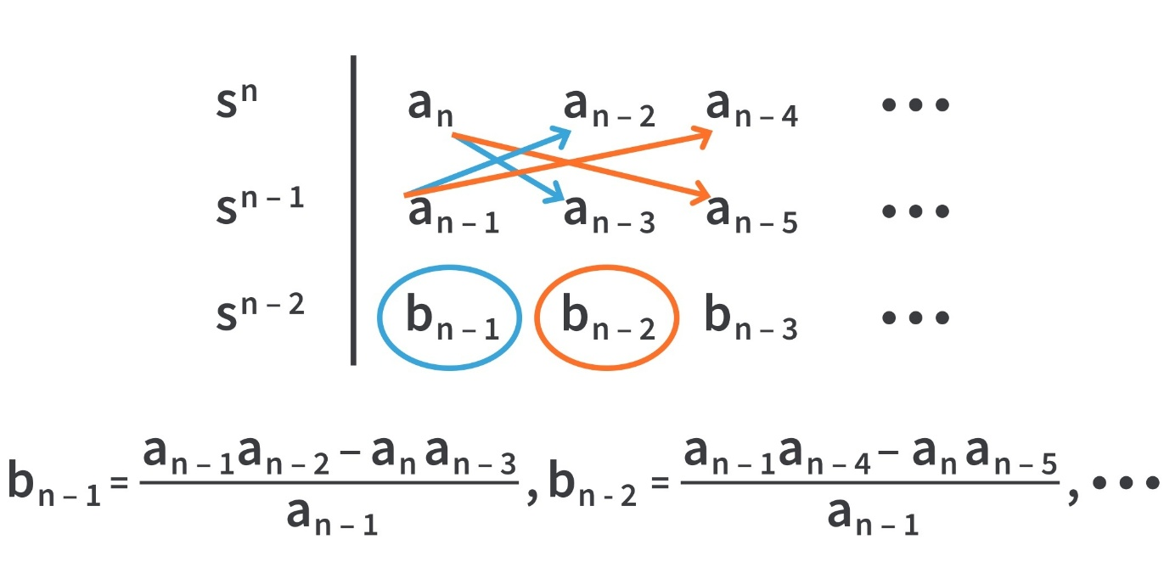
$b_{n-1}$ is the cross multiplication of elements in the first and second columns
$b_{n-2}$ is the cross multiplication of elements in the first and third columns
$b_{n-3}$ is the cross multiplication of elements in the first and fourth columns
……
Repeat this calculation fourth row:
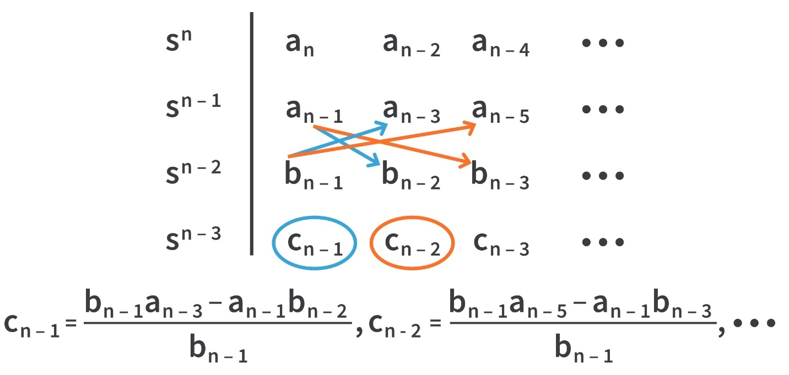
$c_{n-1}$ is the cross multiplication of elements in the first and second columns
$c_{n-2}$ is the cross multiplication of elements in the first and third columns
$c_{n-3}$ is the cross multiplication of elements in the first and fourth columns
……
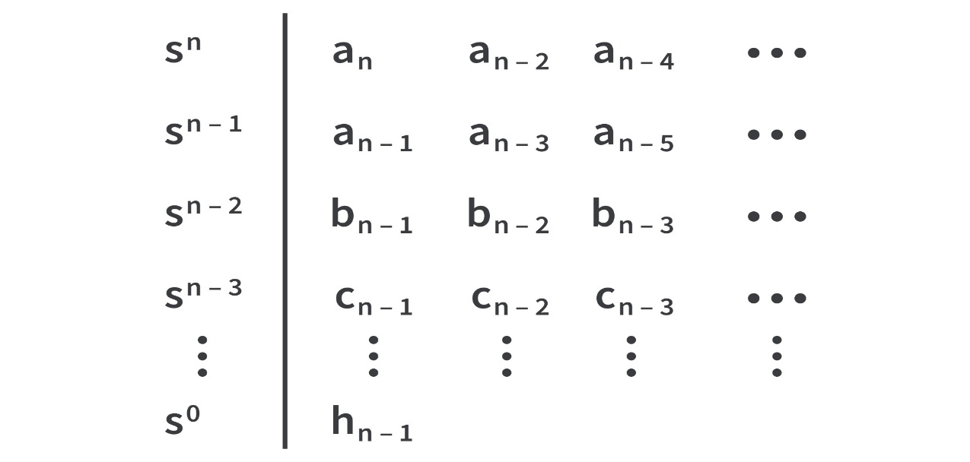
Repeat this calculation till the final row, $s^{0}$. This table is called the Routh Array.

After we have the Routh Array, we then check the sign change in the first column:
If all elements in the first column is positive -> the system is stable
If one or more elements in the first column is not positive -> the system is unstable.
Example: Consider a system with the following characteristic equation:
$$q\left(s\right)=s^{3}+4s^{2}+9s+10$$
Determine the system’s stability.
Solution:
First check coefficients of $q(s)$ -> they should have the same sign -> Yes
Second check missing terms -> No missing terms.
Then, we build the Routh Array.
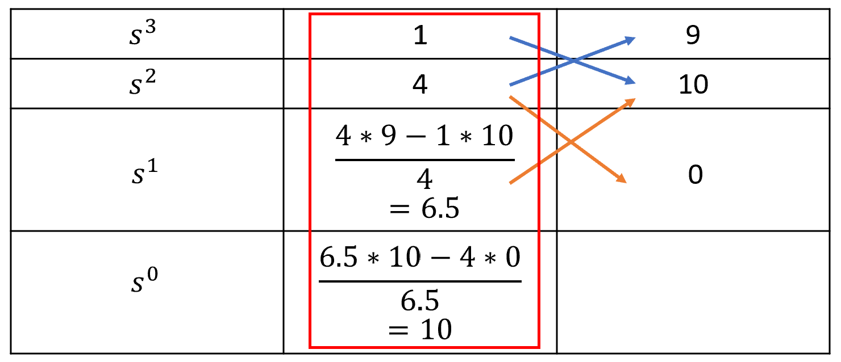
You can see that the elements in the first column are all positive -> system is stable.

Task 1
Let’s create a Routh Array in the MATLAB. Consider a system with the characteristic equation:
$$q\left(s\right)=s^{4}+10s^{3}+32s^{2}+37s+20$$
Determine its stability.
First manually create a Routh Array, then open the sample code (“Lab5_Task1.m”) to create a Routh Array. Compare your manual result with the MATLAB result. Note, when you type in coefficients, use an array ‘[1 10 32 37 20]’.
Task 2
Figure 1 shows the block diagram of the torsion control plant.
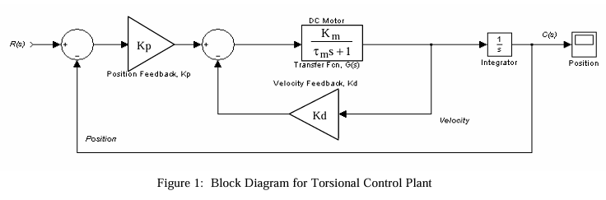
Task 2.1: Starting with the block diagram of the torsional control plant, reduce it to an equivalent closed-loop transfer function. Assume $K_{m}=τ_{m}=1$.
Reference Solution: $\frac{K_{p}}{s^{2}+\left(1+K_{d}\right)s+K_{p}}$
Task 2.2: Apply the Routh-Hurwitz criterion to the denominator of this function to determine the conditions for stability.
Reference Solution: $K_{d}>-1$ and $K_{p}>0$
Task 2.3: Implement Figure 1 in the Simulink. Set the input signal as a step function. Choose values of $K_{p}$ and $K_{d}$ to make the system output stable.
Task 2.4: Implement Figure 1 in the Simulink. Set the input signal as a step function. Choose values of $K_{p}$ and $K_{d}$ to make the system output unstable.

Post lab questions:
- What is meant by the stability of a system?
- How to determine stability of a system?

